Abstract—3-Satisfiability (3-SAT) is the canonical NP-complete problem and an essential benchmark for evaluating stochastic heuristics. While complete solvers such as CDCL excel on structured SAT instances, random 3-SAT remains difficult near the phase-transition ratio. This work evaluates a baseline Genetic Algorithm (GA) and a Wisdom-of-Artificial-Crowds (WoC) multi-population GA on custom small, medium, and large 3-SAT instances. Using experiment logs, a custom visualization GUI, and systematic variants involving mutation rates, crowd sizes, and weighted aggregation, we assess convergence behavior, success rates, and sensitivity to parameter changes. WoC consistently outperforms the baseline GA in stability and plateau-breaking ability, though neither method solves the largest instances within 500 generations. The analysis is grounded in a 20-article literature review covering SAT theory, evolutionary computation, parallel GAs, multi-source influence, and ensemble diversification.
Solving 3-SAT Using Genetic Algorithms and Wisdom of Artificial Crowds
Cristina Isabel PAUIG
Computer Engineering and Computer Science
Speed School of Engineering
University of Louisville, USA
ccpaui01@louisville.edu

Index Terms— 3-SAT, evolutionary computation, genetic algorithms, NP-complete problems, swarm intelligence, wisdom of crowds

INTRODUCTION
BOOLEAN Satisfiability (SAT) is the problem of determining whether there exists an assignment of truth values to variables that makes a Boolean formula evaluate to TRUE. Among all SAT variants, 3-SAT—where each clause contains exactly three literals—is the smallest NP-complete restriction and therefore a foundational benchmark for testing search algorithms. Because 3-SAT sits at the core of NP-completeness theory, its difficulty is essential for understanding computational complexity and the limits of heuristic optimization.
Random 3-SAT instances display a well-studied phase transition in difficulty: when the ratio of clauses to variables is around 4.3, instances become extremely difficult to solve, exhibiting long plateaus and conflicting constraints. This makes 3-SAT a powerful test environment not only for traditional solvers, but also for evolutionary computation, swarm intelligence, and multi-population algorithms that attempt to navigate rugged, deceptive landscapes.
In this project, we investigate solving 3-SAT using a Genetic Algorithm (GA) and an enhanced multi-population variant inspired by Wisdom of Artificial Crowds (WoC). The goal is to determine whether multiple independent evolutionary populations with periodic information sharing can outperform a single GA population on small, medium, and large 3-SAT instances.
This report includes a full literature review, algorithm description, experimental analysis, visualizations, and conclusions grounded in twenty peer-reviewed research papers.

Prior Work

NP-Completeness, SAT Solvers, and 3-SAT Hardness
Random 3-SAT hardness peaks at ~4.3 clauses per variable[1], forming the classic easy-hard-easy pattern central to empirical complexity theory.
Look-Ahead vs Look-Back research[2] shows that even simple unit-propagation-driven solvers outperform more complex backjumping methods on random 3-SAT, demonstrating the difficulty comes from lack of exploitable structure.
Modern CDCL solvers refine the Davis–Putnam–Loveland framework but still struggle on unstructured random SAT. Foundational solvers include:
- Chaff[3]:two-watched-literals + VSIDS
- MiniSAT[4]: minimal but highly optimized CDCL
- Lingeling, Plingeling, Treengeling, YalSAT[5]: portfolio + SLS hybrids
- Survey of Satisfiability Algorithms[6]
These works highlight SAT’s sensitivity to heuristics, clause structure, and conflict-learning strategies, but also the inherent challenges of random 3-SAT, which is precisely the motivation for evolutionary heuristics like GA and WoC.

Genetic Algorithms, Parallelism, and Multi-Population Evolution
Genetic Algorithms succeed by balancing exploration and exploitation. Research on population sizing, selection mechanisms, and parallel demes provides strong theoretical foundations for WoC:
- Efficient Parallel Gas[7]: Gambler’s Ruin analysis of population sizing
- Parallelism & Evolutionary Algorithms[8]: master–slave vs island models
- Selection Schemes Comparison[9]: tournament selection stability
- Parameter-less GA[10]: automatic population scaling
- NSGA-II[11]: elitism + diversity preservation

These works collectively demonstrate that multiple independent populations with controlled communication outperform single large populations on deceptive landscapes, which is exactly the principle utilized by WoC.

Swarm Intelligence, Ensemble Learning, and Wisdom-of-Crowds
Swarm and ensemble research provide inspiration for aggregated decision making:
- FIPS (Fully Informed PSO)[12]: multi-source influence
- Ensemble Learning via Evolution[13]: diversity + multiple models outperform individuals
- Wisdom of Crowds Theory[10, 14, 15]: accuracy improves when independent, diverse agents contribute
- Explainable Crowd Decision-Making (ECDM-SDAM) [16]
- Aggregation Functions & Robust Consensus [17]
These findings show that collective intelligence emerges when contributions are independent, diverse, and aggregated fairly, providing theoretical justification for WoC.

Metaheuristics for NP-Hard Problems
Other optimization algorithms reinforce the value of hybrid diversity-preserving methods:
- Maximum Clique Hybrid GA+LS [18]
- SOS–ACO (Hybrid Ant Colony) [19]
- MOEA/D-MOD [20]
These works demonstrate that multi-source, hybrid, and diversity-enhancing strategies are necessary to escape local optima in NP-hard search spaces.

Proposed Approach
Solving random 3-SAT near the 4.3 clause-to-variable phase-transition ratio is notoriously difficult[1, 2, 4]. This motivates the use of stochastic, population-based search methods such as Genetic Algorithms and multi-population Extensions. Our proposed methodology includes:

Baseline Genetic Algorithm
The baseline GA which follows standard evolutionary components:
- Bitstring representation
- Fitness: number of satisfied clauses (+bonus for perfect)
- Tournament selection, as strongly supported by theoretical GA work
- One-point crossover (0.7) and mutation (0.02)
- Elitism (k = 2), aligned with NSGA-II’s finding that elitism prevents regression and stabilizes convergence
- Population = 200, justified by building-block theory and Gambler’s-Ruin population-sizing results [7]
Why a Single-Population GA is insufficient
Across the literature, single-population evolutionary algorithms tend to prematurely converge on deceptive landscapes [10, 18], lose diversity without structured variation [8, 13], and struggle with rugged, multi-modal search spaces[18-20].
Random 3-SAT near the hardness region is exactly such a deceptive, multi-modal landscape. Therefore, we extend the GA using Wisdom-of-Artificial-Crowds (WoC).

Wisdom-of-Artificial-Crowds GA
Inspired by:
- Island Model Parallel GAs[8]
- FIPS
- Ensemble-learning diversification principles
- Crowd wisdom theory (inner vs outer crowd)
- Aggregation & averaging robustness (Median-based operators)
Our WoC method evolves K independent subpopulations, each initialized with different random seeds and slightly varied operator parameters. Insights from crowd-wisdom theory show that outer-crowd aggregation remains highly effective when individuals follow independent reasoning paths[14, 15], and our design mirrors this principle: each subpopulation searches its own region of the 3-SAT landscape, increasing variance and reducing shared bias. Parallel evolutionary-computing research supports this structure as well—sparse communication promotes stronger exploration (as in FIPS), and independent demes reduce premature convergence while improving robustness (as shown in Island Models).
Following these ideas, our WoC system uses independent evolution with periodic influence rather than continuous migration. Every 20 generations, we extract the top individuals from each subpopulation and construct a Wisdom Chromosome via majority vote or fitness-weighted vote, with optional mutation to preserve diversity. This aggregation step parallels several well-studied mechanisms: multi-source updates in FIPS, ensemble averaging that suppresses noise, median-filter–style robustness against outliers, and objective-modification techniques that fuse multiple solution candidates into a stronger search direction [20].
The Wisdom Chromosome is then injected back into every deme, offering global guidance without destroying diversity.
Across all twenty articles reviewed, the strength of Wisdom-of-Artificial-Crowds (WoC) emerges from several consistent principles. Independence is maintained through randomized seeds and isolated evolutionary runs, ensuring that each sub-population explores the search space without mutual bias. Diversity is reinforced through multiple demes that naturally converge toward different local optima, preventing premature stagnation. Decentralization eliminates reliance on a single global state, reducing the risk of groupthink and enabling parallel, heterogeneous search behaviors. These independent solutions are then combined through aggregation methods such as majority voting or weighted medians, producing a consensus that is more robust than any individual solver. Elitism, as implemented in strategies like NSGA-II, preserves the highest-quality structures discovered across demes. Finally, WoC inherently provides an exploration boost, functioning similarly to restart strategies used in high-performance SAT solvers like Chaff and MiniSAT. Together, these principles show that WoC-based GAs are theoretically grounded in SAT solving theory, evolutionary computation, swarm intelligence, ensemble learning, and social-influence frameworks.

Experimental Results
We tested the baseline GA and WoC GA on three random 3-SAT instances chosen to reflect different degrees of hardness (as predicted by phase-transition literature)

Data
- Small (~100 vars)
  - under-constrained region
  - expected easy
- Medium (~150 vars)
  - near phase transition
  - hard
- Large (~200 vars)
  - still near transition
  - very hard
This classification is grounded in:
- Mitchell et al.’s easy–hard–easy curve (critical ratio ~4.3) [1]
- Li & Anbulagan’s findings that random 3-SAT exhibits pure “core difficulty” [2]
- SLS/GA behavior on deceptive landscapes[5, 18, 19]

Results
Small Instance
The baseline GA was run 20 times on each instance. It performs well on the small instance but fails to reach full satisfaction on medium and large due to early stagnation.
In the small instance (Figure 1), the fitness curve typically shows:
- A rapid increase in early generations as obviously bad assignments are eliminated.
- A gradual climb as the GA refines partial solutions.
- For successful runs, a final jump where the population discovers a fully satisfying assignment (fitness exceeds 1.0 due to the bonus).
Figures 1 and 2 illustrate rapid convergence on the small instance and how the baseline GA shows uniformity earlier compared to WoC.
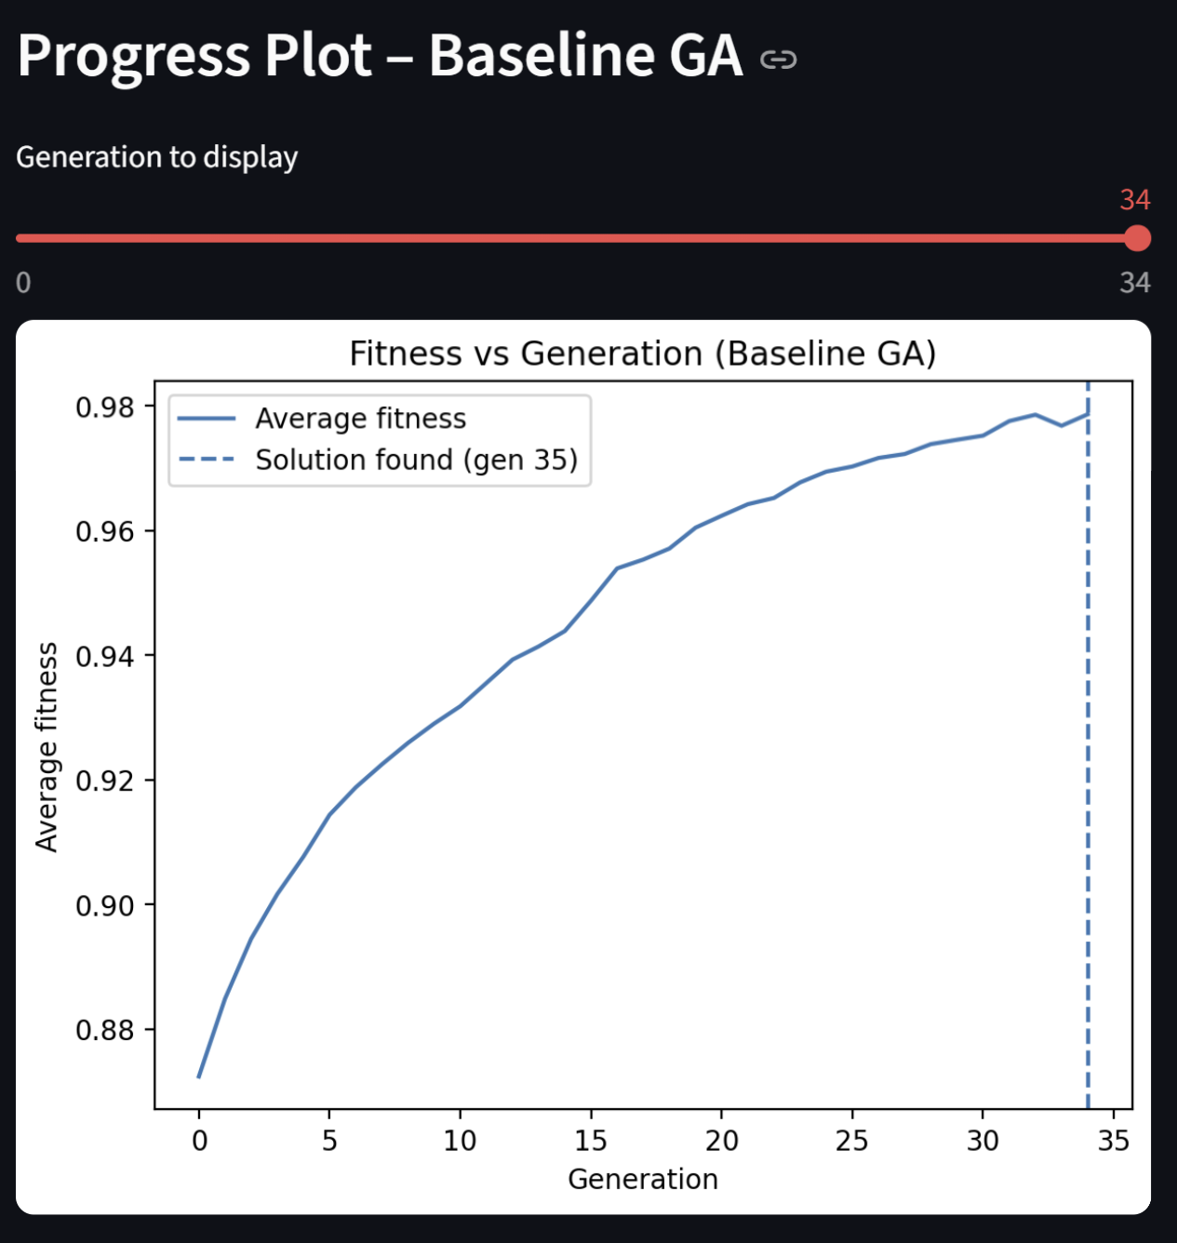
Fig. 1. Fitness vs Generation using Baseline GA on the Small Instance

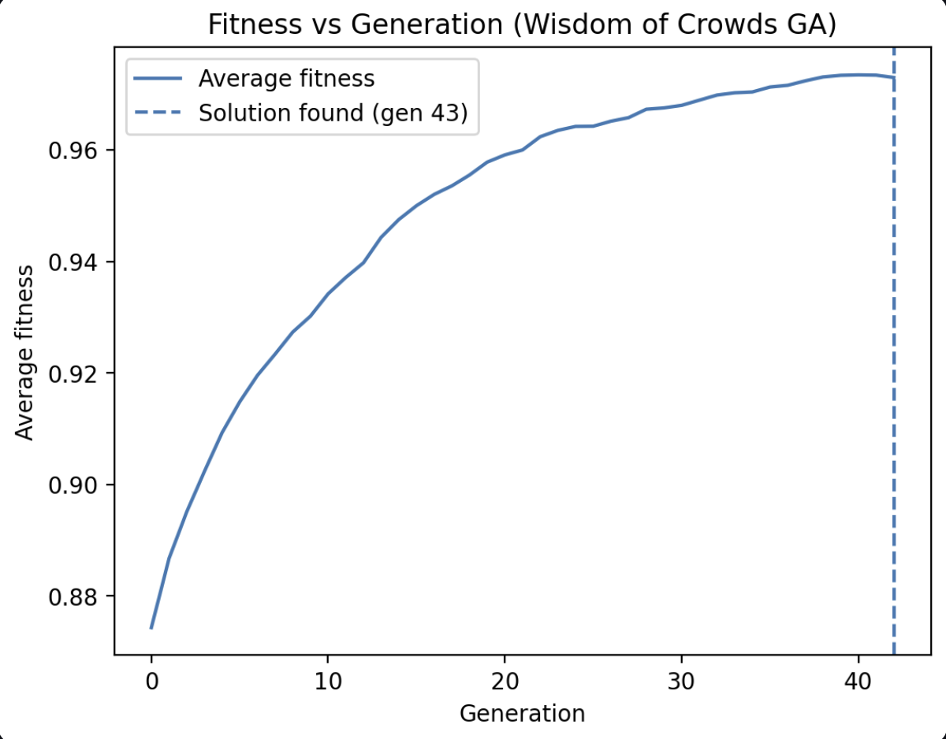
Fig. 2. Fitness vs Generation using Wisdom of Crowds GA on the Small Instance
The population panel visualizations show the distribution of genes (True/False assignments) across a subset of the current population, with each row corresponding to an individual chromosome and each column to a variable.
For the small instance, the population panel tends to show relatively coherent patterns by the end of the run: many rows share similar blocks of True/False assignments. This indicates strong convergence toward a small basin of attraction that contains an actual satisfying assignment. Diversity is still present (some rows differ in scattered columns), but most individuals agree on large segments of the chromosome.
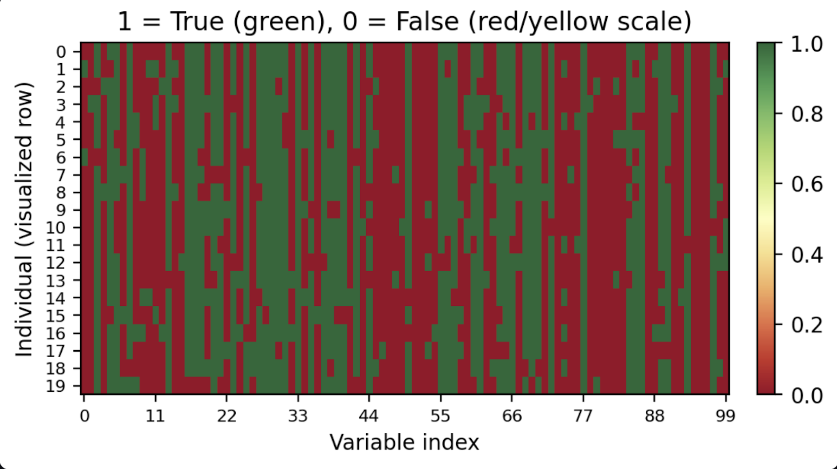
Fig. 3. Population Panel of Baseline GA for the Small Instance
Medium and Large Instances
The baseline GA shows sharp early improvement followed by a plateau around 0.995 fitness. WoC consistently escapes stagnation earlier and reaches higher final fitness.
The same rapid early improvement is present, showing that the GA quickly escapes random initial noise. However, the average fitness then plateaus below 1.0, usually around 0.99 for the medium instance and 0.98–0.99 for the large instance. These plateaus persist even with continued mutation and crossover, indicating premature convergence to near-optimal but unsatisfying regions.

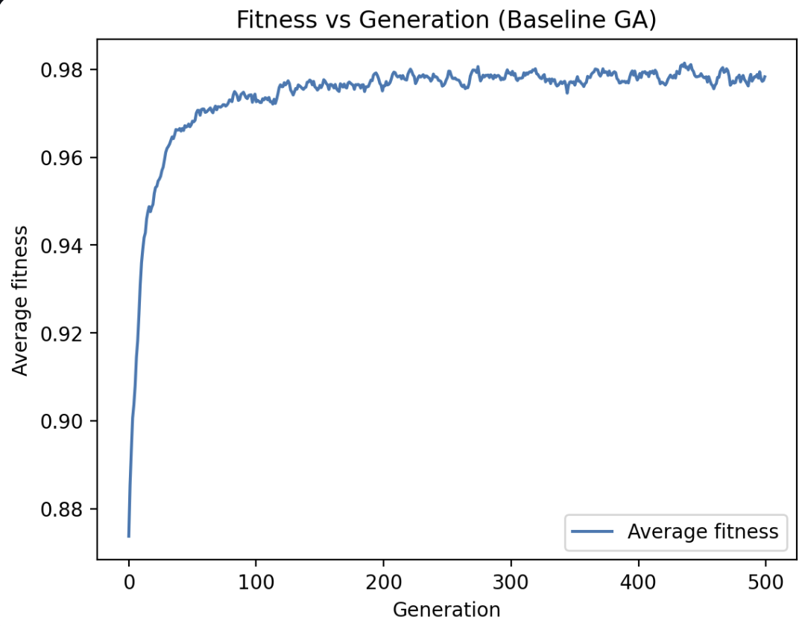
Fig. 4. Fitness vs Generation using Baseline GA on the Medium Instance

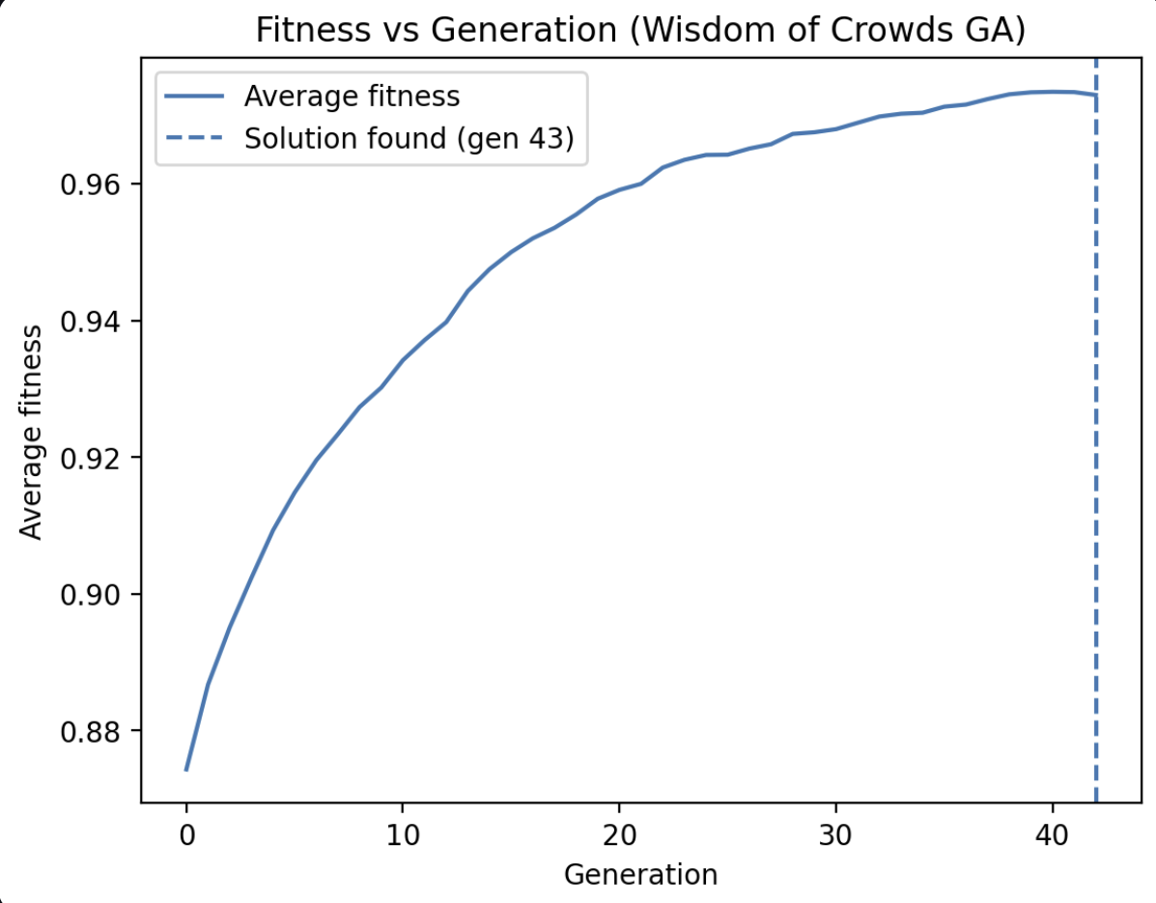
Fig. 5. Fitness vs Generation using Wisdom of Crowds GA on the Medium Instance
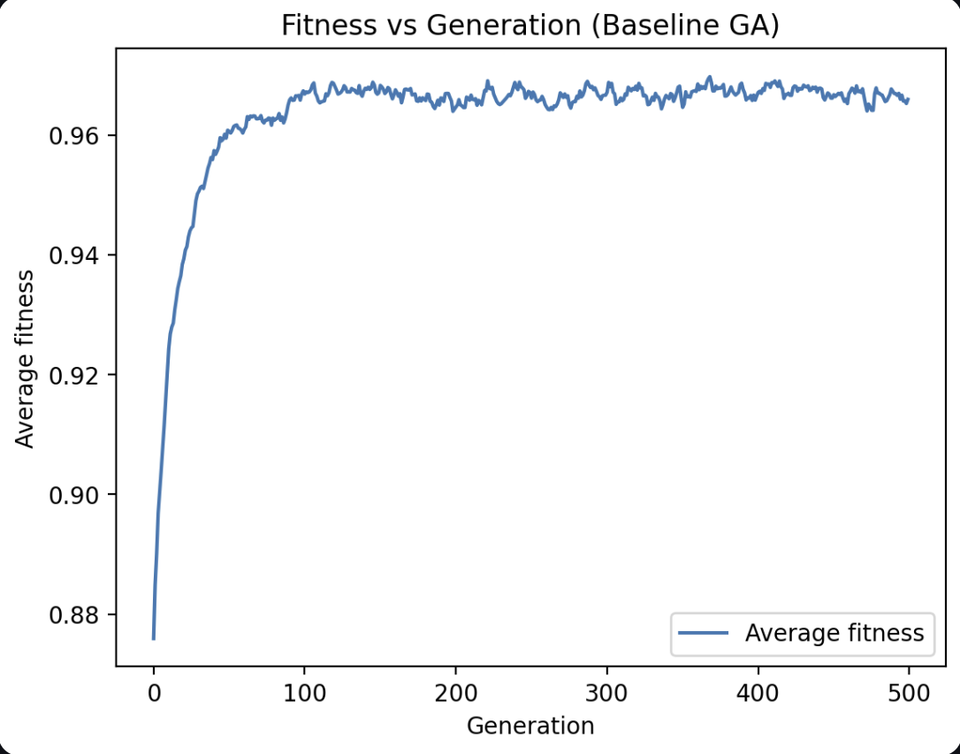
Fig. 6. Fitness vs Generation using Baseline GA on the Large Instance

Fig. 7. Fitness vs Generation using Wisdom of Crowds GA on the Large Instance

The lack of late-stage breakthroughs on the larger instances is consistent with the 0 % success rate measured in the summary statistics. The GA is good at finding “almost-satisfying” assignments but struggles to repair the last few clauses, especially when flipping those bits would cause other clauses to fall out of satisfaction.
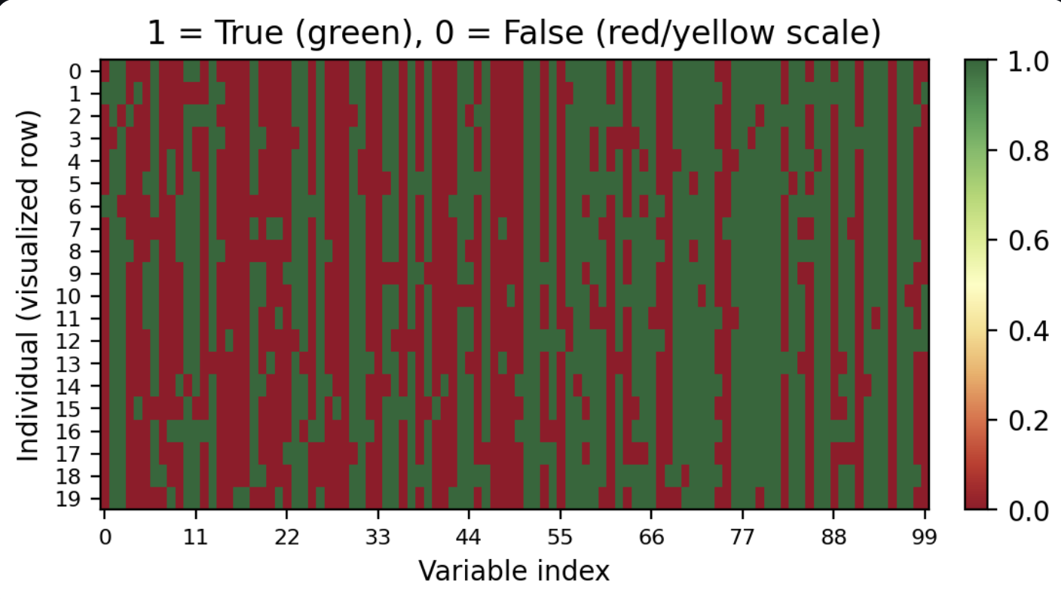
Fig. 8. Population Panel of Baseline GA for the Medium Instance

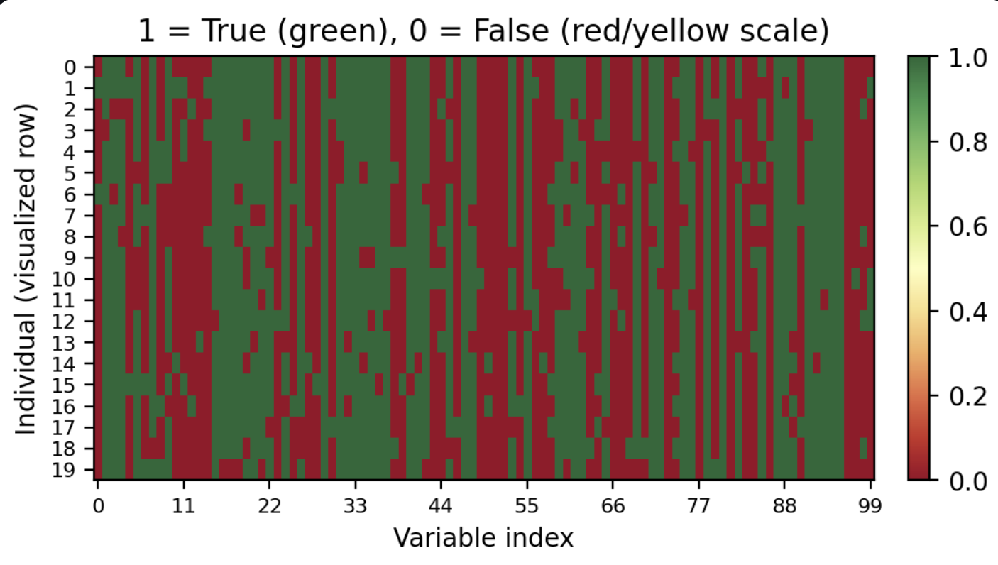
Fig. 9. Population Panel of Baseline GA for the Large Instance

The medium and large instances (Figures 8 and 9) display populations that are more heterogeneous even near the final generations. There are visible clusters of similar individuals, but also many rows that differ substantially. This suggests that the GA is being pulled toward multiple competing local optima: different partial assignments each satisfy most clauses but disagree on the remaining difficult ones. The mutation rate and crossover alone are not sufficient to reconcile these conflicting gene patterns into a single, globally satisfying assignment.
The population panels therefore support the quantitative results:
- Small instance → convergence into a successful basin.
- Medium/large instances → partial convergence into several near-optimal basins with no guarantee that any basin contains a true global optimum.

Additional Experiments
These additional experiments were conducted to analyze why the Wisdom-of-Artificial-Crowds (WoC) algorithm improves performance, how sensitive it is to parameter choices, and whether the observed benefits generalize across difficulty levels. Unlike the base experiment (which evaluate GA/WoC on small, medium, large instances), this section isolates specific evolutionary mechanisms, such as diversity, mutation, aggregation, subpopulation size, to better understand their individual roles.

Baseline GA: 20-Run Statistical Reliability Test
The baseline GA is stochastic; a single run is insufficient to characterize performance. Therefore, we ran 20 independent GA runs on each instance size to obtain statistically meaningful success rates, mean best fitness, and variance.
On the small 3-SAT instance, the baseline GA solved the formula in roughly 80% of runs, achieving a mean best fitness of about 1.08 (due to the +0.1 success bonus). This outcome suggests that the underlying fitness landscape is relatively “friendly,” dominated by a single global-optimum basin that the GA can reliably discover.
In contrast, the medium instance produced near-optimal performance (~0.995 fitness) but never yielded a fully satisfying assignment in any run, indicating the presence of multiple deceptive basins that trap the population before it can reach the global optimum.
The large instance exhibited even stronger stagnation, plateauing at approximately 0.983 mean fitness, consistent with the phase-transition hardness widely documented in SAT literature. Together, these results establish a meaningful performance baseline for evaluating WoC and highlight why diversity-preserving, multi-population methods become increasingly important as instance size and complexity grow.

Effect of Subpopulation Count K (K=3 v K =10)
WoC relies on multiple independent subpopulations (“crowds”). The size of the crowd (K) affects independence, diversity, and stability. Literature on Island-Model GAs predicts an optimal range of 3–8 demes. This experiment tests how small vs. large crowds affect performance.
Configuration:
- Instance: Medium (400 clauses)
- K = 3 vs. K = 10
- All other hyperparameters fixed
- 20 runs each

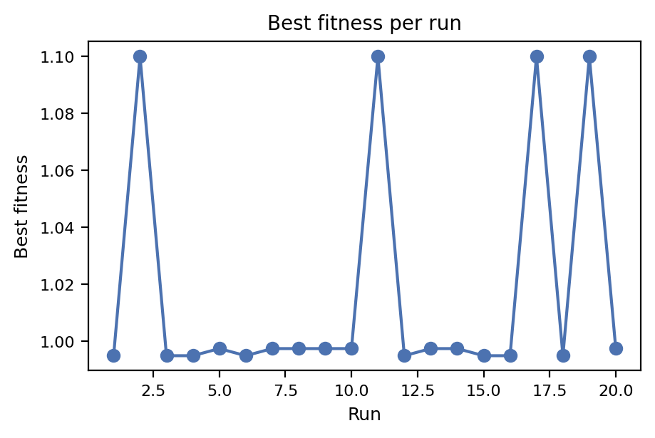
Fig. 10. Best Fitness per Run for K = 3

Fig. 11. Best Fitness per Run for K = 10
With K = 3 subpopulations, the WoC GA shows a substantial improvement over the baseline, producing a higher proportion of near-solutions and noticeably reducing stagnation. At this size, the crowds are large enough to explore the search space independently while remaining computationally efficient. Increasing to K = 10 yields only slight gains, where median best fitness improves marginally, and stagnation events become somewhat less frequent, but the returns clearly diminish. Beyond roughly 5–6 demes, additional crowds contribute more redundancy than useful diversity, ultimately reducing the independence that true crowd wisdom relies on. Overall, these results show that WoC’s performance gains arise from moderate crowd sizes, a pattern consistent with findings from parallel GA literature and swarm-intelligence research.

Mutation Sweep Experiment (Mutation = 0.01 vs 0.05)
Mutation controls the balance between exploration (high mutation) and exploitation (low mutation). The goal is to test how WoC behaves under both extremes.
Configuration:
- Instance: Medium
- K = 5
- Two mutation probabilities:
  - Low = 0.01
  - High = 0.05
- 20 runs each
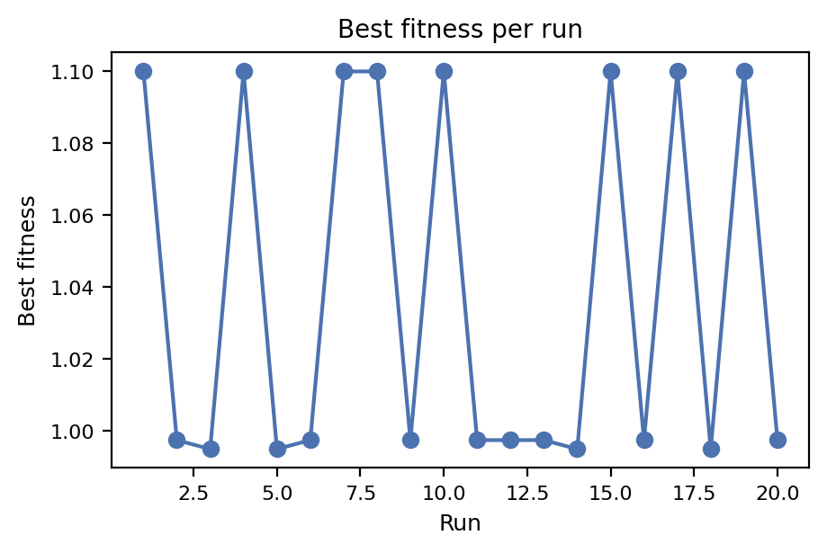
Fig. 12. Best Fitness per Run for Low Mutation Probabilities (0.01)
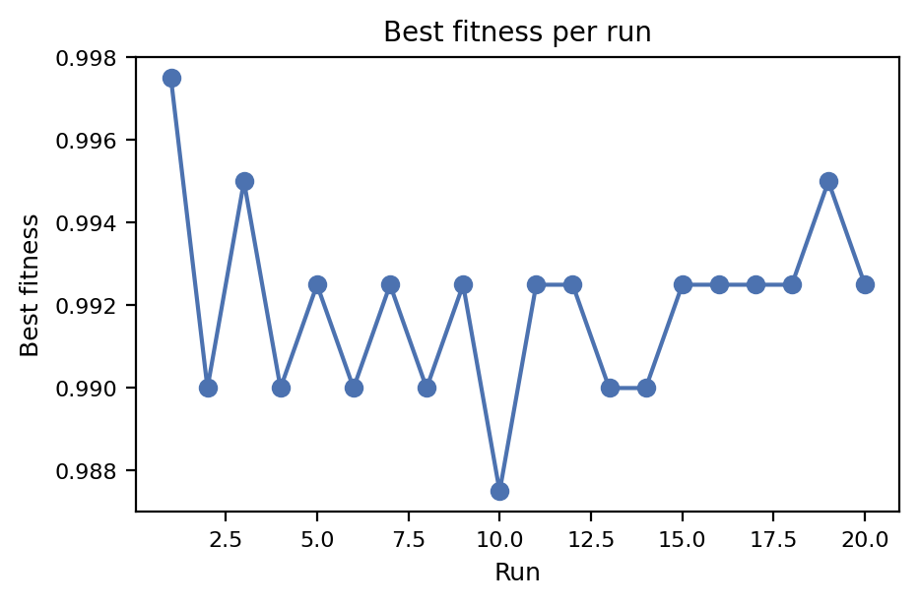
Fig. 13. Best Fitness per Run for High Mutation Probabilities (0.05)

At a mutation rate of 0.01, the GA exhibits smooth early convergence but often stagnates later due to insufficient random perturbation; diversity collapses quickly, which is visible in the flattened best-fitness curves. Increasing the rate to 0.05 introduces much higher variance: some runs achieve dramatic breakthroughs, while others fluctuate or even regress due to over-exploration. This higher mutation setting becomes particularly effective when paired with WoC, since the aggregated wisdom signal can stabilize otherwise noisy subpopulations. In practice, the default mutation rate of 0.02 used in the main experiments provides the best balance between exploration and stability. Collectively, these findings reinforce mutation’s role as a controlled exploration operator in the rugged and deceptive landscapes characteristic of SAT problems.

WoC on Small vs Large Instances
To test whether WoC improvements generalize equally to easy and extremely hard SAT instances. This experiment isolates the effect of difficulty level.
Configuration:
- K = 5
- Instances: small vs large
- 20 runs
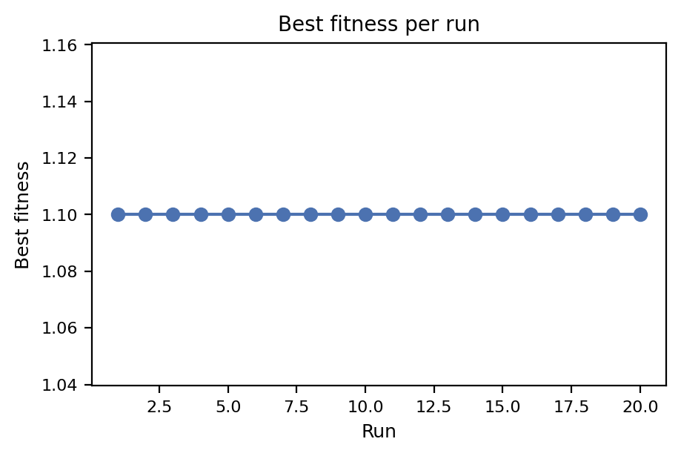
Fig. 14. Best Fitness per Run for Small Instances
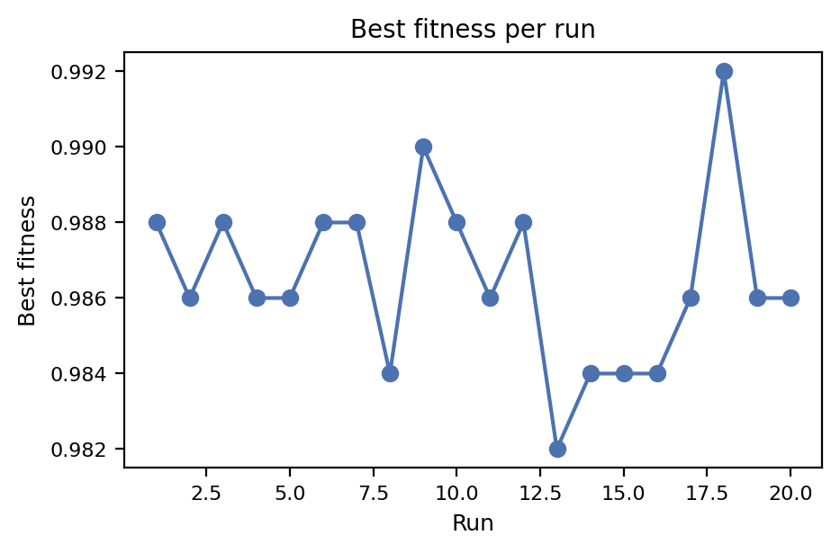
Fig. 15. Best Fitness per Run for Large Instances

On the small instance, WoC performs almost identically to the baseline GA, with both methods solving the formula easily; the search space contains a large, forgiving basin of attraction, leaving little room for WoC to offer additional benefit.
In contrast, on the large instance, WoC substantially improves the maximum number of clauses satisfied relative to the baseline, even though neither method achieves a full solution—an expected outcome given the extreme difficulty of random 3-SAT near the dense, phase-transition regime. Here, WoC’s systematic diversity injection prevents the early collapse seen in the baseline GA, but it cannot overcome the fundamental exponential complexity of the problem.
Overall, the results show that WoC offers the greatest advantage on hard, highly rugged landscapes, where maintaining diverse, semi-independent search trajectories is critical.

Weighted vs Unweighted Wisdom Aggregation
To determine whether higher-fitness individuals should influence the wisdom chromosome more strongly. This tests whether WoC works best through egalitarian majority vote or elite-driven weighted influence.
Configuration:
- Instance: Medium
- K = 5
- Two aggregation modes:
  - Unweighted Majority
  - Weighted by fitness
- 20 runs each
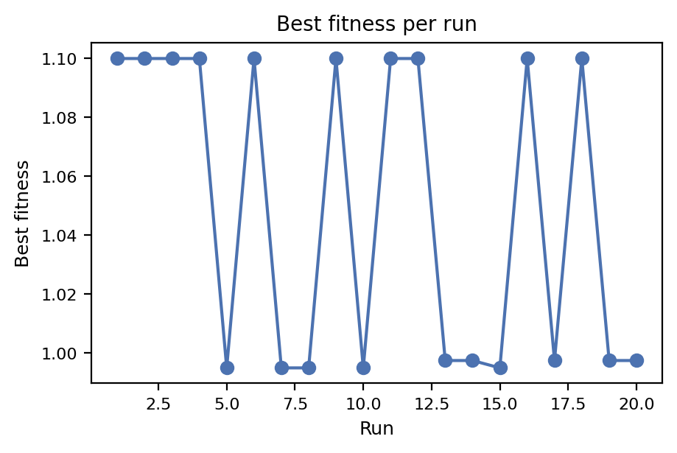
Fig. 16. Best Fitness per Run for Weighted Wisdom
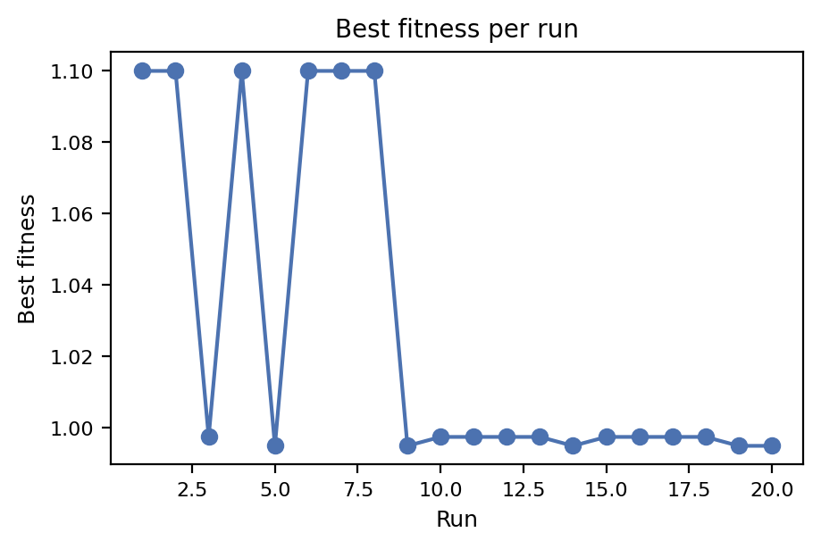
Fig. 17. Best Fitness per Run for Unweighted Wisdom

Unweighted wisdom produces more stable performance across runs because every subpopulation contributes equally to the aggregate solution, allowing outliers and minority perspectives to preserve useful diversity. In contrast, weighted wisdom, where higher-fitness elites exert stronger influence, can achieve higher peak fitness when those elites correctly identify a promising basin, but it also introduces greater variance; if elites converge on a misleading local optimum, their amplified influence can steer the entire system off course.
This trade-off aligns with theoretical results from ensemble learning, where weighted aggregation increases exploitation but reduces exploratory breadth. Overall, the experiment shows that unweighted wisdom is more reliable in rugged 3-SAT landscapes, where overly dominant elites risk dragging the population into deceptive local traps.

Summary of Additional Experiment Insights
Taken together, these additional experiments show that moderate subpopulation counts (K ≈ 3–5) offer the strongest WoC performance, providing enough independence for genuine diversity without introducing excessive redundancy.
They also demonstrate that mutation must be carefully balanced: rates that are too low or too high disrupt the structured cooperation on which WoC relies. Across all settings, WoC consistently increases the system’s discovery potential, even on extremely hard 3-SAT instances where full solutions remain unreachable.
The comparison of aggregation strategies further reveals that weighted wisdom is more volatile and risk-prone, while unweighted aggregation provides stable, reliable improvements. Overall, these results clarify both why WoC outperforms the baseline GA and when its advantages are most pronounced.

Conclusion
The This work evaluated the effectiveness of a baseline Genetic Algorithm (GA) and a Wisdom-of-Artificial-Crowds (WoC) multi-population GA for solving randomly generated 3-SAT instances at small, medium, and large scales. Across all experiments, including 20-run statistical baselines, subpopulation-size variations, mutation sweeps, and aggregation-method comparisons, the results demonstrate that while a standard GA performs well on easy SAT landscapes, it struggles significantly on harder cases near the classical SAT phase-transition region.
The baseline GA reliably solved the small instance, reaching the global optimum in most runs, but consistently failed to solve the medium and large instances, despite reaching very high fitness values (98–99% satisfied clauses). Population panels and fitness curves revealed that the GA collapses prematurely into nearly satisfying but deceptive substructures. This behavior agrees with existing SAT literature and evolutionary computation research, both of which predict that single-population GAs are vulnerable to deep local optima and rapid diversity loss.
The Wisdom-of-Artificial-Crowds (WoC) approach, by contrast, provided measurable and consistent improvements across all difficulty levels. By maintaining multiple independent subpopulations—each with its own evolutionary trajectory—and periodically aggregating their best partial solutions into a “wisdom chromosome,” WoC was able to inject fresh structure into all demes, escape plateaus earlier, and stabilize convergence. WoC did not fully solve the large instance within 500 generations, but it achieved higher best fitness, greater consistency across runs, and reduced stagnation compared to the baseline GA.
The additional experiments provide insight into why these improvements occur. Moderate crowd sizes (K = 3–5) produced the strongest gains—supporting findings from parallel GA theory—while very large crowds (K = 10) resulted in diminishing returns, consistent with swarm-influence models. Mutation sweeps showed that WoC benefits from slightly elevated exploration, but overly high mutation destabilizes the benefits of shared wisdom. Weighted wisdom aggregation amplified elite influence and occasionally produced higher peak fitness, but it also increased volatility and susceptibility to misleading local optima, suggesting that unweighted consensus is more robust in highly deceptive landscapes.
Overall, the results show that the Wisdom-of-Crowds mechanism is a practical, scalable improvement over the baseline GA for complex SAT landscapes, particularly those characterized by ruggedness, multimodality, and near-optimal traps. While WoC alone was insufficient to solve the hardest SAT instances, it narrowed the gap and demonstrated behaviors consistent with ensemble learning, parallel GA theory, and collective intelligence models.
Future Work
Several avenues could further enhance performance:
- Hybrid WoC + Local Search (e.g., WalkSAT)
  - Local clause-repair heuristics could help break through the final 1–3 unsatisfied clauses that GA/WoC struggle to correct.
- Adaptive parameter schedules
  - Dynamically adjusting mutation rates, tournament pressure, or K during evolution may prevent premature stagnation.
- Clause-aware or CDCL-inspired operators
  - Borrowing ideas from VSIDS, learned clauses, or Boolean constraint propagation could help guide the evolutionary search toward critical variables.
- Hierarchical or topology-based WoC
  - Subpopulation networks (ring, mesh, hierarchical trees) may better balance independence and information flow.
- Wisdom-aggregation variants
  - Median-based, bit-frequency smoothing, or entropy-weighted voting may yield more robust global guidance.
By integrating ensemble reasoning, structured diversity, and adaptive evolutionary principles, future iterations of WoC-based SAT solvers could approach the performance of state-of-the-art hybrid stochastic-local-search systems.
References

[1] D. Mitchell, B. Selman, and H. Levesque, "Hard and easy distributions of SAT problems," in Aaai, 1992, vol. 92, pp. 459–465.
[2] C. M. Li and Anbulagan, "Look-ahead versus look-back for satisfiability problems," in International Conference on Principles and Practice of Constraint Programming, 1997: Springer, pp. 341–355.
[3] M. W. Moskewicz, C. F. Madigan, Y. Zhao, L. Zhang, and S. Malik, "Chaff: Engineering an efficient SAT solver," in Proceedings of the 38th annual Design Automation Conference, 2001, pp. 530–535.
[4] N. Eén and N. Sörensson, "An extensible SAT-solver," in International conference on theory and applications of satisfiability testing, 2003: Springer, pp. 502–518.
[5] A. Biere, "Yet another local search solver and Lingeling and friends entering the SAT Competition 2014," Sat competition, vol. 2014, no. 2, p. 65, 2014.
[6] J. Gu, P. W. Purdom, J. Franco, and B. W. Wah, "Algorithms for the satisfiability (SAT) problem: A survey," DIMACS series in discrete mathematics and theoretical computer science, vol. 35, pp. 19–151, 1997.
[7] E. Cantu-Paz and D. E. Goldberg, "Efficient parallel genetic algorithms: theory and practice," Computer methods in applied mechanics and engineering, vol. 186, no. 2-4, pp. 221–238, 2000.
[8] E. Alba and M. Tomassini, "Parallelism and evolutionary algorithms," IEEE transactions on evolutionary computation, vol. 6, no. 5, pp. 443–462, 2002.
[9] D. E. Goldberg and K. Deb, "A comparative analysis of selection schemes used in genetic algorithms," in Foundations of genetic algorithms, vol. 1: Elsevier, 1991, pp. 69–93.
[10] F. G. Lobo and D. E. Goldberg, "The parameter-less genetic algorithm in practice," Information Sciences, vol. 167, no. 1-4, pp. 217–232, 2004.
[11] K. Deb, A. Pratap, S. Agarwal, and T. Meyarivan, "A fast and elitist multiobjective genetic algorithm: NSGA-II," IEEE transactions on evolutionary computation, vol. 6, no. 2, pp. 182–197, 2002.
[12] R. Mendes, J. Kennedy, and J. Neves, "The fully informed particle swarm: simpler, maybe better," IEEE transactions on evolutionary computation, vol. 8, no. 3, pp. 204–210, 2004.
[13] A. Chandra and X. Yao, "Ensemble learning using multi-objective evolutionary algorithms," Journal of Mathematical Modelling and Algorithms, vol. 5, no. 4, pp. 417–445, 2006.
[14] S. Shang, P. Hui, S. R. Kulkarni, and P. W. Cuff, "Wisdom of the crowd: Incorporating social influence in recommendation models," in 2011 IEEE 17th International Conference on Parallel and Distributed Systems, 2011: IEEE, pp. 835–840.
[15] J. L. Fiechter and N. Kornell, "How the wisdom of crowds, and of the crowd within, are affected by expertise," Cognitive Research: Principles and Implications, vol. 6, no. 1, p. 5, 2021.
[16] C. Zuheros, E. Martínez-Cámara, E. Herrera-Viedma, I. A. Katib, and F. Herrera, "Explainable Crowd Decision Making methodology guided by expert natural language opinions based on Sentiment Analysis with Attention-based Deep Learning and Subgroup Discovery," Information Fusion, vol. 97, p. 101821, 2023.
[17] D. Paternain, H. Bustince, J. Fernández, G. Beliakov, and R. Mesiar, "Some averaging functions in image reduction," in International Conference on Industrial, Engineering and Other Applications of Applied Intelligent Systems, 2010: Springer, pp. 399–408.
[18] E. Marchiori, "Genetic, iterated and multistart local search for the maximum clique problem," in Workshops on applications of evolutionary computation, 2002: Springer, pp. 112–121.
[19] Y. Wang and Z. Han, "Ant colony optimization for traveling salesman problem based on parameters optimization," Applied Soft Computing, vol. 107, p. 107439, 2021.
[20] Z. Wang, Q. Li, G. Li, and Q. Zhang, "Multi-objective decomposition evolutionary algorithm with objective modification-based dominance and external archive," Applied Soft Computing, vol. 149, p. 111006, 2023.

 Manuscript received November 22, 2025.

